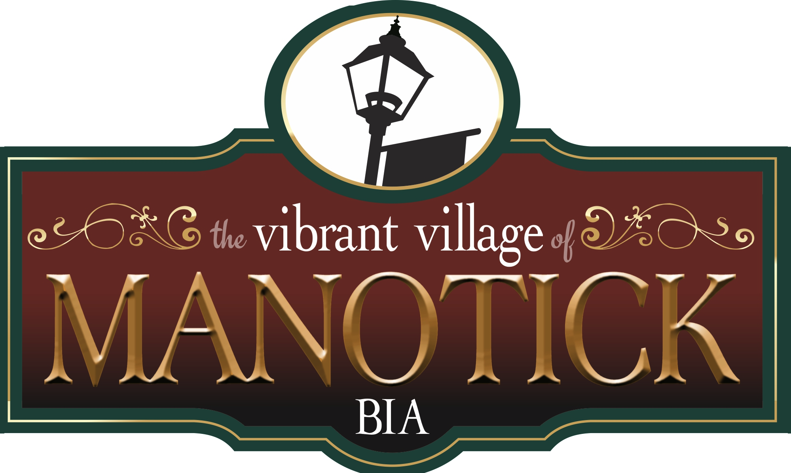

Manotick BIA, Board of Management Meeting

Friday October 13, 2023

Black Dog Bistro, Manotick Main Street.

**Call to Order**

Motion to call to order at 8:06a.m.

Moved by Michelle Vandenbosch, Seconded by Michael Mirsky

Carried

**Approval of Agenda**

Motion to approve the agenda:

One correction to agenda….Small Business Breakfast date is Thursday October 19th, not Thursday October 20th as noted on the agenda.

Moved by Sarah Wright, Seconded by Michelle Vandenbosch

**Approval of Minutes**

Motion to approve the Minutes

One correction to minutes…..participants will be listed as “Board Members” or “Guests”….not together.

Moved by Dot Janz, Seconded by Sarah Wright

**Attendance**

**Executive**

Kris Gordon, Chair Ken Gordon Holdings

Michelle Vandenbosch, Vice-Chair Rebel Petal Designs

Leila Hojabi, Treasurer Desjardins Financial

**Board Members**

Michael Mirsky Landlord

Sarah Wright The Wright Team, Team Realty

Kyra Gillis Mansfields Shoes

David Brown City of Ottawa Councillor

Dot Janz Black Dog Bistro

Laura Glasper 692 Coffee and Bar

Amanda Cameron North Station Provisions

Dianne Pritchard Just Imagine Inc.

George Michaliszyn Nin Collection

**Members who joined by Zoom**

Kelly Belair Executive Director

**Guests**

Christine McGahey Lollies and Scoops

Gary Coulombe Manotick Messenger

Paula Agostin Alllure Hair Design

Michelle Sekerres Allure Hair Design

Joshua Stanley Manotick Martial Arts

Heather Brophy St. James Anglican Church

Robin Holmes Robin Lea Photography

**Chair’s Report**

Kris welcomed everyone to the meeting with the following comments:

This is a special meeting today as we celebrate “Small Business Month” Congratulations to each of you for the success of the businesses you are part of. And thank you for taking time to be here today. I hope many of you will be able to join us at the Manotick/Barrhaven Small Business Breakfast on the 19th of October

We acknowledge the Algonquin Anishinaabe Nation, whose traditional and unceded territory we are gathered on today.

Conflict of Interest Declaration: Michelle Vandenbosch indicated that she has a conflict with the discussion surrounding “Christmas in the Village” and her role as Ms. Claus.

Kris thanked Dot for hosting us and providing the yummy scones and coffee for our meeting.

It has been an interesting couple of weeks since we last met, with the publication on the Auditor General’s report and the subsequent news/media coverage. Thank you all for holding the line and not engaging with the media.

The new Finance Policy Committee will hold their first meeting on October 24th. Reports will be forthcoming once the work of the committee has concluded.

At our last meeting I indicated that a report would also be coming out from the Integrity Commissioner’s office. We anticipate that this could happen towards the end of October. Perhaps as soon as the 25th of the month. Once again, there could be a flurry of media attention. Your executive will develop a Board response once the report is shared with us.

And finally, we were asked to meet with Anne Robinson, on behalf of the new “Dock Extension” group. They are looking for Manotick BIA involvement/sponsorship to proceed with the extension of the dock. I believe that before we agree to participate, we need to have a fulsome discussion to determine if there is a business case for proceeding with support. This Board would need to have a formal motion to approve participation.

The main question is:

Does the dock actually bring business to our village.

Kris opened this portion of the meeting to discussion.

David Brown pointed out that the extension of the dock discussions should be part of a larger picture. There is a significant need for sidewalks, crosswalk, and parking should the dock be extended. Pedestrian accessibility should be a priority. There should be a feasibility study pertaining to new growth in the village, additional traffic concerns and whether or not the dock extension will indeed bring more business to Manotick.

The Board agreed that a business case must be developed to justify BIA involvement.

The Executive Director will send a survey to all BIA members to solicit feedback. A discussion on the survey results will take place at the next meeting.

**Executive Director’s Report**

Kelly was ill and could not attend the meeting. She did however, participate by ZOOM.

In her absence, Kris as Chair, read Kelly’s report.

***Taste of Manotick:***

Moving the date proved to be a success judging by the number of people who attended

Having the street licensed created an atmosphere that allowed people to mingle freely on the street

Now that the city and AGCO have approved the licensing of the street it will make it easier next year as we now have a template with the city that we just need to renew next year.

Key takeaways and lessons learned:

People liked the earlier start for the event but going to 8pm was too late. The consensus was the event hours should be 2pm to 6pm.

A huge shout out to the Kiwanis Club volunteers especially Neil Usher who assisted with the street closure, barricades and fencing.

Next year we can’t rely on Volunteers to install all of the fencing.

Kelly suggests having the supplier install most of the fencing to line the streets on Friday with the exception of the fronts of businesses and side streets.

On Saturday volunteers would be needed to assist with putting the side street fencing in place.

The labour costs are too high to have the fencing installed by the supplier on Saturday.

The entire street should be fenced from Beaverwood to the Gateway at Bridge and Main.

We should definitely look at programming to include the Mews next year as well, however those merchants that come from the Mews to the street definitely see the benefits of being part of the action on the Main St.

Will look into a car show again, having a stage in the Mews, some roaming performances/activities in the Mews.

One challenge as it is with every event, is confirming member participation, when members don’t register in a timely manner it bottlenecks the process of preparing site plans etc.

A shout out to those businesses who were innovative in their participation in the event and thinking outside of the box and bringing some excellent added ideas to the street that day.

If anyone still has funds for the Manotick Food Cupboard could you please let Kelly know so that she can add it to the tally of the total funds raised.

Next year’s date, Labour Day falls on September 2nd. We will need to confirm Richmond Fair, usually the 3rd weekend, Kelly proposes the event be whichever date is not Richmond or Metcalfe Fair

Event Feedback Survey:

78% were satisfied or very satisfied with the event

78% were satisfied with the September event date

77% were satisfied with the 2pm to 8pm event times

Consensus was the timing be 2pm to 6pm

77% were satisfied with the entertainment

The survey comments will be taken into consideration when planning next year's event.

***Women’s Day - Saturday, November 4th***

Promo material is being distributed on Monday

Member participation form has been sent out - Deadline to be included in the passport - Tuesday of next week

Kelly encouraged businesses to think about what they can offer for this event, Babbos will be doing a cooking demonstration, [Leila Hojabri](mailto:leila.hojabri@desjardins.com) our Treasurer and Kelly are discussing a seminar about women in business.

Kelly will need to order the balloons for this event but welcomes any insight into other ways to identify the businesses that are participating. Distributing the balloons is always an issue. Not everyone wants balloons either. Kelly welcomes thoughts on this.

If anyone would like to assist planning the various Women’s Day events, 2 or 3 members please put your name forward to Kelly.

***Christmas in the Village - December 1st and 2nd***

Promo material will be ready to promote at Women’s Day.

Kiwanis Parade of Lights, tree lighting and caroling on Friday.

Wilson Law has already been in touch about offering hot chocolate during the parade, please let Kelly know if any one else will be handing out hot beverages for the parade.

A suggestion was made to have a Light Up Your Business/Storefront competition amongst the members with various categories to be launched on December 1st for the Parade.

MVCA would also like to collaborate with us on this initiative to include decorating residential houses.

Kelly is looking for a couple of volunteers to assist with the planning of Christmas in the Village event.

Kelly is suggesting that a schedule be prepared for Santa and Mrs. Claus and they can travel to the various locations for the appointed times.

She is recommending this as last year Millers Oven was too small to accommodate everyone for the breakfast and the Legion did a breakfast as well, which was confusing.

This way the establishments can plan what they wish for, for the day and we can arrange for Santa and Mrs Claus to visit during the appointed times.

If you are planning on having your own Santa in the village that weekend we would encourage you to coordinate with Kelly in advance. Last year there were 4 Santa’s in the village that day and it caused confusion amongst the children.

We encourage you to book your time with our Santa and Mrs. Claus on Saturday or book your Santa on another day or weekend.

The BIA pays Santa and Mrs. Claus for their services that day. Mrs. Claus is our Vice-Chair

Michelle declared a conflict and left the room after providing the Board with history and background.

Currently the person providing the service as “Ms. Claus” for the Saturday of Christmas in the Village weekend, is paid $500.00.

The Board is being asked to approve the continuation of this payment.

Motion to Approve the continuation of $500.00 payment each, to the individuals playing both Ms. Claus and to Santa Claus.

Moved by Dianne Pritchard, Seconded by Dot Janz

Motion approved unanimously.

***South Ottawa Small Business Networking Breakfast - October 19th - Stonebridge***

Celebrate Small Business Week with fellow small business owners in Ottawa's South, Co-hosted by Manotick Village BIA , Barrhaven BIA and Ottawa Coalition of Business Improvement Areas (OCOBIA).

N﻿etworking and Hot Breakfast at Stonebridge Golf Club including:

-﻿ Updates by City of Ottawa for Ottawa South wards:

* David Brown , Councillor for Rideau-Jock
* D﻿avid Hill, Councillor for Barrhaven West

Small Business panel discussion moderated by Wilson Lo, Councillor for Barrhaven East

Topic: Change in work patterns (hybrid, remote) and the impact on small businesses in the suburban/village landscape.

The cost is $10 to attend - Hoping for a good representation from the businesses from Manotick

We need catering numbers for next week so if you are planning on attending please purchase your ticket as soon as possible!

***Banner Update:***

Veterans Banners are up in 19 locations on the Remembrance Day parade route

We are having a final committee meeting next week to discuss how long the banners will be up and the next steps

Kelly is currently getting quotes to replace the winter banners

She has received 3 quotes for the Christmas decor which will be installed following Remembrance Day. Nutri Lawn/Christmas Decor Ottawa will be the contracted supplier for the next 3 years.

They came in within budget. We don’t have to maintain or store the decorations. Nutri-Lawn maintains it, ensures lights are functioning etc.

The other two quotes did not fall within our budget.

A suggestion was made that we look at holiday decor of whites and blues vs green and red Christmas colours - This way the decorations can stay up longer over the winter months.

Promotes a holiday look vs Christmas.

***2024 Budget:***

Kelly is in the process of working on the budget for 2024 for presentation at the next board meeting

***Branding/Website RFP:***

In Kelly’s absence, Sarah presented this portion of the report.

The committee has awarded the contract to our existing web support company, Patrick from Blue Eclipse and Lissa Constantine from Bird Dog Design.

The pair is collaborating on the project.

The committee was impressed with their proposal and they came in under budget.

Next steps will be preparing the Creative Brief with the committee to be completed before Christmas.

Then a focus group will be developed to go through the concepts in early January.

Target date for implementation will be spring of 2024 so that we are ready for new Summer banners and Spring Fling in April.

**Councillor Brown Report**

The City will meet during the 1st week of November to review Councillor Brown’s request for sidewalk restoration as one “repair bundle” in order to work more efficiently with the companies who will undertake the tasks.

The Mayor is supportive of the issue of truck traffic through the village and hopefully there will be some mention of it in the City budget in late November.

Crosswalk lights are under discussion for 2024 budget item. Councillor Brown has requested higher visibility and a paint refresh.

**Motion to Adjourn**

Motion to adjourn at 8:51a.m.

Moved by Mike Mirsky, Seconded by Sarah Wright

Carried