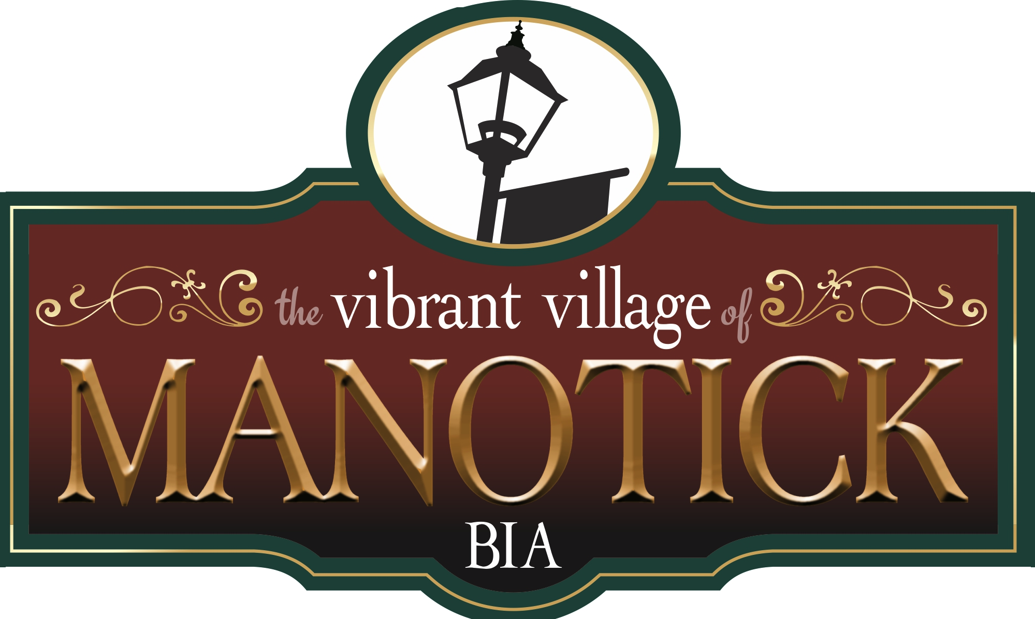

Manotick Business Improvement Area

Board of Management Meeting

Friday November 10, 2023, 8:00a.m.

Royal Canadian Legion, Manotick Branch 314

5550 Ann St. Manotick

Kris Gordon, Chair of the Board invited everyone to introduce themselves, given that the Integrity Commissioner and her assistant were also in attendance.

Attendance

**Executive**

Kris Gordon, Chair Ken Gordon Holdings

Michelle Vandenbosch, Vice-Chair Rebel Petal Designs

Leila Hojabi, Treasurer Desjardins Financial

**Board Members**

Michael Mirsky Landlord

Sarah Wright RLP, The Wright Team

Kyra Gillis Mansfield’s Shoes

Darpan Ahluwalia Manotick Natural Market

Adam McCosham Home Hardware

Laura Glaspar 692 Coffee and Bar

Amanda Cameron North Station Provisions

Shannon Giust Salvaged

Dianne Pritchard Just Imagine Inc.

David Brown City of Ottawa, Councillor

**Executive Director**

Kelly Belair

**Guests**

Sheila Stewart Manotick Office Pro

Jim Steward Manotick Office Pro

Leanne Van der Burgt YOMA

Melissa MacIssac ROSSS

Nicole Rosenfeldt Royal Lepage Team Realty

Stephanie Bousquet Manotick Nursery School

Irene Staron MVCA

**Call to Order**

**Motion to Call to Order at 8:08am**

Moved by Michelle Vandenbosch, Seconded by Sarah Wright

**Carried**

Chair’s Welcome

Kris welcomed everyone to our new meeting venue. Future meetings will be held at the Legion, we hope everyone is comfortable here.

Kris acknowledged that this meeting is occurring on unceeded territory of the Algonquin Anishinaabe Nation.

There are some new agenda items that will occur on a monthly basis, and at times we will be inviting a guest speaker to attend. This month, our guest is Karen Shepherd, City of Ottawa Integrity Commissioner.

Kris reminded everyone that only Board Members can speak at Board meetings, all other meeting participants are here as observers only, unless invited to speak by the Chair.

Additions to Agenda

Laura requested to be able to speak about Christmas in the Village.

Kris informed everyone that the Budget discussions on the draft budget, and the final budgets for both Taste of Manotick and for Women’s Day will be deferred to the December meeting.

Approval of Agenda

**Motion to approve the agenda as amended for November 10, 2023**

Moved by Mike Mirsky, Seconded by Dianne Pritchard

**Carried**

Approval of Minutes of October 13th

Adam requested that his name be added as he attended the meeting by ZOOM.

**Motion to approve the minutes as amended**

Moved by Amanda Cameron, Seconded by Dianne Pritchard

**Carried**

Guest : Karen Shepherd, City of Ottawa Integrity Commissioner

Kris turned the meeting over to Karen Shepherd.

Karen explained her role with the City as Integrity Commissioner. She is responsible for issues surrounding integrity and ethical standards in the City. In addition she is also responsible for ensuring the Code of Conduct is being respected for all City operations and is the City “Meetings Investigator”

As such, Karen would be happy to return to the Board and deliver a session on Board Member responsibilities.

Karen briefly discussed how the Integrity Commissioner became involved with Manotick BIA, and explained that the recommendations and final report were public knowledge.

Karen then invited Board Members to come forward with any questions. There were no questions.

Kris then asked for a motion:

**Motion**

Motion to accept the Integrity Commissioner’s Report and Recommendations

Moved by Sarah Wright, Seconded by Dianne Pritchard

**Carried**

Kris thanked Karen Shepherd for attending the meeting.

Karen and her assistant then left the meeting.

**Chair’s Report**

Kris asked if there were any Declarations of Conflict of Interest for this meeting. There were no declarations at this time.

Kris reminded everyone to sign in on the sheets provided.

Kris also reminded everyone that there are a couple of new items added to the agenda that will become regular reporting items. These are the Treasurer’s Report and the Policy Committee report.

The final budget will be presented for Board approval at the December meeting.

Kris spoke to the Board….it been a tumultuous time for the current Board with two ongoing investigations. We have survived, (and for some of us, it seemed like survival) and we will continue to thrive as a BIA. I would like to personally thank each of you for your ongoing commitment to Manotick and for your support as we navigated these very unusual waters. It is my honour to be Chair of this Board working with such strong business owners who demonstrate their support for each other every day.

To that end, I would like to host a Board Retreat in December. My idea is that this would take the form of a social event for casual conversation and discussion. I’m looking for a venue to accommodate this, please let me know of any suggestions you might have. I will be in touch with you all to arrange this event.

**Executive Director’s report**

*Women’s Day

By all accounts the day was a great success. The weather was good, there was excellent attendance and the streets seemed full. Thank you to everyone for their support and participation. There will be a survey sent out next week to collect data on successes and challenges. The information will be shared at the next Board meeting.

There was a brief discussion about some businesses not being involved. In many cases, the issues were related to the businesses not responding to messages inviting them to participate. Although there were at least three instances of businesses not receiving the correct info. Kelly will investigate and report back to the Board.

The executive will review a suggestion that an Annual Events Calendar be published to include all MBIA events. This calendar would be widely distributed to Village businesses.

**Beautification Project**

Kelly is investigating the feasibility of hanging banners over the Main Street as a way of drawing attention to upcoming events. Kelly will report back at the next meeting on this exciting initiative.

Once the rebranding project is complete the new spring banners will be hung throughout the village. There will be 140 new heavy duty banners.

**Christmas in the Village Plans**

Promotional material is being distributed today. Please let Kelly know if you have not received it.

Most programming is complete, some final details to work out.

Village business decorating should be complete by the 1st of December in time for the “ Kiwanis Parade of Lights”. Please register through Kelly to participate in the parade.

Carollers are booked for Friday night and Saturday. There will be horse drawn carriage rides, hot chocolate, (Please let Kelly know if you intend to offer hot chocolate, currently there are two venues, Wilson Law and Morning Owl, sponsored by Home Hardware) holiday gift wrapping, Bazaar at the Legion, Watson’s Mill Craft market, Letters to Santa station, and Ornaments Crafting station.

Kris has suggested using the former ROSSS building on Mill ST. for some of these activities. Kelly will follow up.

Santa and Mrs. Claus will be available throughout the weekend event.

Village Decorating Contest

Irene Staron was invited to describe the Village Decorating Contest being sponsored by MCCA, and supported by the Manotick BIA. There will be contests for both businesses and residences, in the area of Traditional, Inflatable, WOW, and Humour. There will be 6 judges, Kris was volunteered to be one of them. Judging will take place from December 16-19. Please check the MCVA websit for detailed information.

**Tree Lighting**

As the discussion was related to Christmas in the Village, Laura requested the opportunity to bring her item forward.

In the past, 692 Coffee and Bar sponsored a tree lighting that co-incided with Village festivities. This has worked well and last year, the big tree outside Watson’s Mill was chosen as the tree and was very successful. However, there is significant cost to stringing the lights etc and Laura is requesting Board support for this cost. Purchasing the lights will be through Adam and businesses are invited to contribute to this cost.

**Motion**

Motion to approve $500.00 for tree light stringing etc and taking down. Funds to come from the “Christmas in the Village” budget line.

Moved by Michelle Vandenbosch, Seconded by Adam McCosham

**Carried Unanimously**

*Remembrance Day Service

The parade will commence at 10;15-10:30 through the streets to the Cenotaph. Kelly will lay the wreath on behalf of the MBIA.

*Manotick Messenger Articles

Kelly has been approached by the Messenger to undertake the development of a Manotick BIA article in each issue.

The Executive Committee believes this would be a great opportunity to feature MBIA activities and reinforce the purpose of the MBIA. At the same time it could highlight different village businesses. Kelly would create the MBIA content and requests that there be a rotating responsibility for articles highlighting various businesses.

Adam and Amanda volunteered to work with Kelly on this initiative.

**Councillor David Brown report**

David has an appointment scheduled with City of Ottawa Public Works to walk though the village to review infrastructure requirements. Painting of the village lamp posts will fall under this discussion.

In response to a question regarding the proposed traffic circle at the corner of Barnsdale and Rideau Valley Drive, David confirmed that the Works department was surveying the property last week and is included in the 2024 budget.

**Policy Committee Update**

Kris presented the following report on the work of the policy committee.

The Policy Committee has met once in October and will be meeting again this month.

To date we have reviewed the requirements from the Auditor General report and determined that there are a number of policies required.

Our priority will be to develop the policies to respond to the Auditor General Report with the completion date of the end of Q1. The committee will then consider other policies which this Board needs to have in place.

As mentioned previously, we anticipate the work of the Policy Committee will be ongoing and will report monthly to the Board until the work has been completed.

**New Business**

Chair for Charity

Adam reported that $2000.00 was raised for YOMA through the Chairs for Charity project this year.   
Adam intends to run the Chairs for Charity project again this year and has sourced chairs which are painted white and will cost $100. Each. If businesses are interested, he would like to get started on this project, in the early spring and will be ordering the chairs in the New Year. Please let Adam know if you are interested in participating.

**Motion to Adjourn**

Motion to Adjourn at 8:59am

Moved by Dianne Pritchard, Seconded by Michelle Vandenbosch

**Carried.**

Next Meeting Friday December 8th, 8:00am